CSSE463 Image Recognition

Lab 4 Edge Detector

Zesun Yang

[yangz@rose-hulman.edu](mailto:yangz@rose-hulman.edu)

December 18, 2017

1. **Abstract**

In image recognition, just being able to recognize and set threshold for colors or HSVs is not enough. In this lab, I learned to find object characteristics such as elongation and circularity, and used these characteristics to set new thresholds for the system to differentiate shapes.

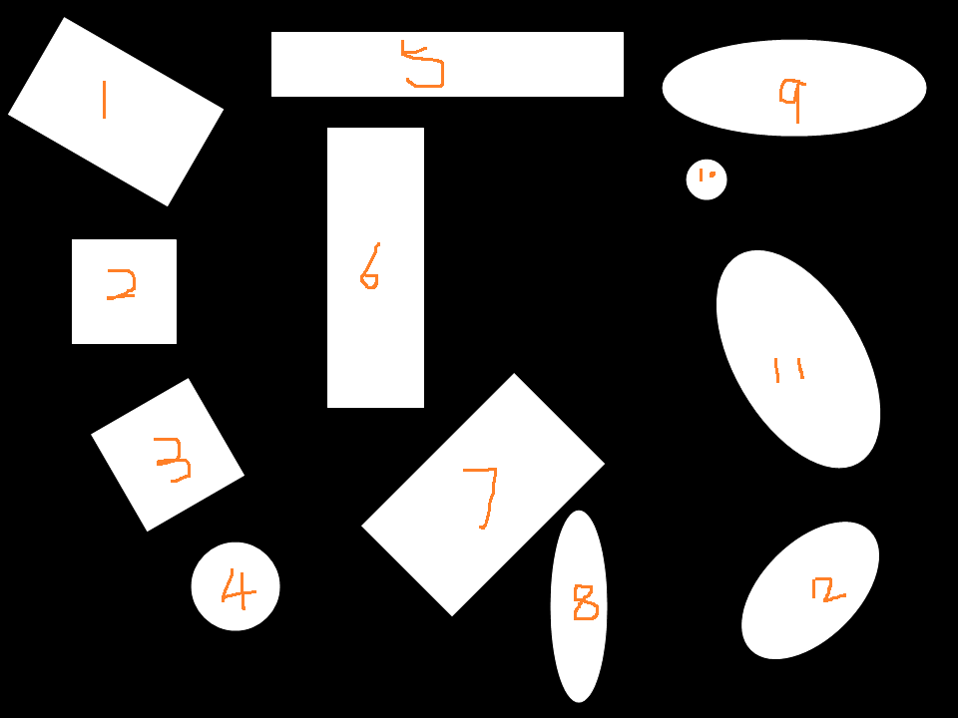

This is the given image. The goal of the lab to isolate these shapes, compute their elongations and circularities, and let the system distinguish 4 different shapes according to the computed characteristics and thresholds.

1. **Shape values**

|  |  |  |
| --- | --- | --- |
| Shape and number | Elongation | Circularity |
| Rectangle #1 | **1.6326** | **19.2195** |
| Square #2 | **1** | **15.6967** |
| Square #3 | **1.0006** | **17.9076** |
| Circle #4 | **1.0005** | **13.7120** |
| Rectangle #5 | **5.4314** | **30.1688** |
| Rectangle #6 | **2.8970** | **20.7471** |
| Rectangle #7 | **1.6739** | **16.8302** |
| Ellipse #8 | **3.3498** | **22.2165** |
| Ellipse #9 | **2.7170** | **19.4053** |
| Circle #10 | **1.0065** | **13.3026** |
| Ellipse #11 | **1.8601** | **15.9116** |
| Ellipse #12 | **1.7334** | **15.3773** |

1. **Rules**

In the shape classifying process, one difficulty is that, the rectangles and ellipses has similar elongation and circularity. But that is not surprising because rectangles can be drawn as ellipses in which their internal angles are 90 degrees. To achieve a more accurate classification, I set two thresholds for rectangles, one is small rectangles, and another is the large rectangles.

Based on computed shape characteristics, I believe the following thresholds are reasonable:

Small rectangle has elongation between 1.6 and 3, circularity less than 25.

Large rectangle has elongation that goes above 4, circularity goes above 25.

Ellipse has elongation between 1.7 and 4, circularity between 16 and 25.

Square has elongation of around 1, and its circularity is between 15 and 19. Because the xx, yy, xy variances for squares are not very different

Circle has elongation slight above 1 (1.005-1.1), and circularity around 13. Circle has the least circularity.

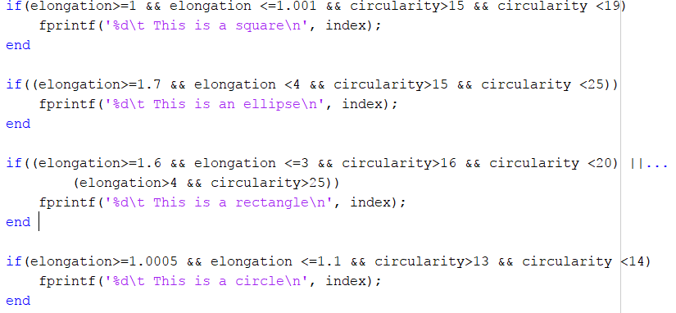

1. **Result**

|  |  |
| --- | --- |
| True class | Detected |
| Rectangle #1 | **Rectangle** |
| Square #2 | **Square** |
| Square #3 | **Square** |
| Circle #4 | **Circle** |
| Rectangle #5 | **Rectangle** |
| Rectangle #6 | **Ellipse X** |
| Rectangle #7 | **Rectangle** |
| Ellipse #8 | **Ellipse** |
| Ellipse #9 | **Ellipse and rectangle X** |
| Circle #10 | **Circle** |
| Ellipse #11 | **Ellipse** |
| Ellipse #12 | **Ellipse** |